

Department of Computer & Software Engineering
College of E&ME, NUST, Rawalpindi

Microcontroller and Microprocessor Based Design
Project Report

Title: Neo Octane by MADS

Group Members:
Saad Rasheed – Reg # 337909
Ammad Ali – Reg # 346904
Mashaal Ibne Masha Allah – Reg # 341923
Daniyal Zahid – Reg # 359080

Abstract— The main aim of this project is to construct a remote-controlled vehicle using a microcontroller (ESP32). A smartphone will be used to control the movement of the vehicle. Tilting the phone will move the vehicle in the corresponding direction. This can be achieved using the smartphone’s built-in gyroscope. The vehicle will be equipped with 4 motors and 4 fixed wheels, and a motor controller will be used to control the speeds of said motors. To provide an interface to the user, we’ll be using an application called Blynk IoT. This will provide the user with ability to control the vehicle as well as receive feedback from it regarding any collision or possible collision. The vehicle will be equipped with proximity sensors to prevent the vehicle from any collisions from nearby objects. To power the automobile and the microcontroller, rechargeable batteries will be used.

Parts:
🧠 Arduino Uno
👨‍✈️ L298N Motor Driver
🎡 Motors and Wheels (4)
🏠 Chassis
🔋 18650 rechargeable batteries (3)
🚨 Infrared Sensors (2)
📡 Bluetooth Module (HC-05)
🔊 Buzzer
📺 OLED Screen
🔌 Jumper wires
📌 Breadboards

🧭Navigation:
To navigate the car, an interface on Blynk IoT has been created. The buttons are used to move the car forward or backwards. The slider is used to control the speed of the car. Values from slider and buttons are sent to Blynk, which in turn sends it to the ESP.
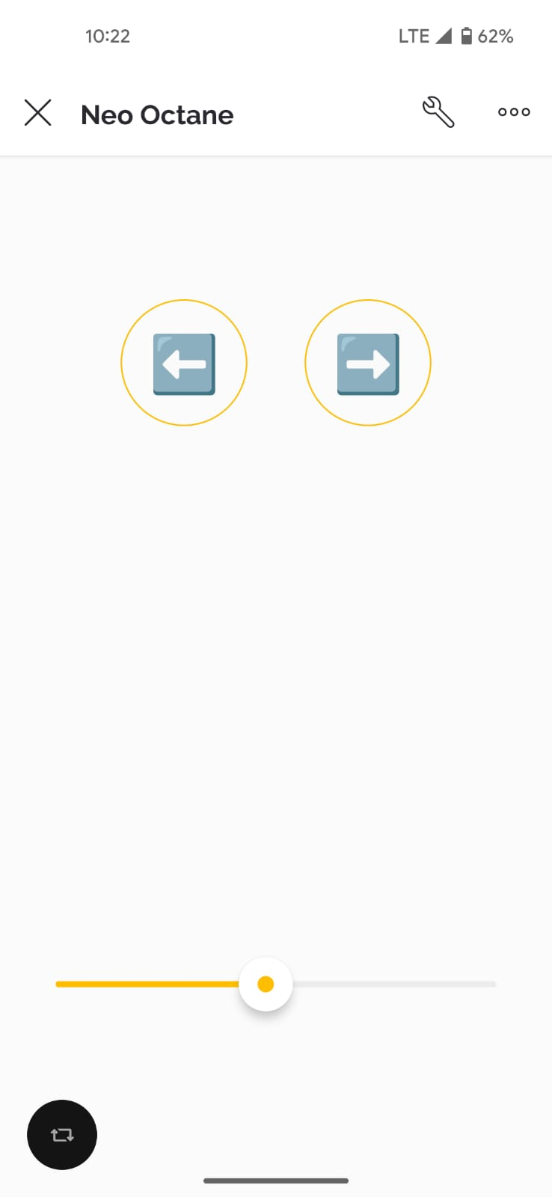
To steer the car, user must tilt the phone. The phone’s accelerometer value is sent to ESP through Dabble app which is casted into motor speeds. To turn the car to the right, the right motor speeds are set higher than the left motor and vice versa for the left.
🏎️Locomotion:
L298N is the brain behind motor control. Our main power supply, 3 18650 batteries, are connected to this module. The 5-volt supply from the module is used to power ESP32.
OUTA and OUTB are used to control two motors each for each side. ENA (enable A) is used to control the speed of the OUTA motors. ENB (enable B) is used to control the speed of OUTB motors. IN1 and IN2 are used together to control the direction of OUTA motors. IN3 and IN4 are used together to control the direction of OUTB motors.
IN(1/3) | IN(2/4) | Motor(A/B)
LOW | LOW | Stop
LOW | HIGH | Forward
HIGH | LOW | Backward
HIGH | HIGH | Stop

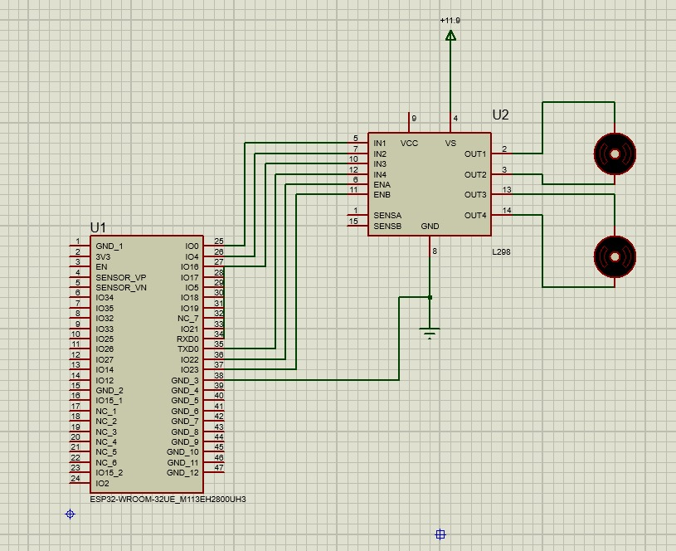
⚠️Obstacle Avoidance:
To avoid crashing into obstacles, ultrasonic sensor and trigger switches work together. Ultrasonic sensor calculates the distance between the car and any obstacle in front of the car. If the distance is lesser than a threshold value, the car will not move forward, and the user is notified of the obstacle on the interface. In case the obstacle is of low profile and the ultrasonic sensor cannot detect it, the car will bump into the obstacle and the trigger switches will be triggered. This will send an interrupt to the ESP which will in turn send notification to the user.

🔮Future work:
- Create a separate app to navigate the car and provide a more intuitive interface to the user.
- Add a camera at the front of the car and show feed to the user.

